

**A 12**

**Sreenidhi Institute of Science & Technology**

(An Autonomous Institution)

**CODE NO: 121ME02**

**B. TECH. I – YEAR II – SEMESTER EXAMINATIONS, JULY, 2014 (REGULAR)**

**ENGINEERING DRAWING – II (Common to ECE, CSE & BT)**

**Time: 3 Hours Max. Marks: 70**

**Note: No additional answer sheets will be provided.**

**Part-A**

**Max.Marks:20**

**Answer all QUESTIONS.**

1. An area of 144 sq.cm on a map represents an area of 64 sq.km on the field. Find R.F of the scale for the map.
2. What are the applications of development of surfaces?
3. Draw the isometric view of pentagonal pyramid with its axis vertical. Side of the pentagon=25mm and axis of the pyramid=60mm.
4. Differentiate between the oblique projection and isometric projection.
5. Define angle of vision and auxiliary ground plane.
6. Write any four editing commands used in CAD.
7. Write any three differences between first angle projection and third angle projection.
8. How do you classify scales in engineering? Name them with their application.
9. What are the different coordinate methods used in CAD to locate a point?
10. What are the methods of drawing perspective view?

**Part – B**

**Max. Marks: 50**

**ANSWER ANY FIVE QUESTIONS. EACH QUESTION CARRIES 10 MARKS.**

1. Construct a diagonal scale of 1:4000 to show meters and long enough to measure upto 600metres. Show a length of 243 m and 309 m on it.
2. Construct a scale of R.F.= 1: 2.5 to show decimeters and centimeters and by a vernier to read mm, to measure upto 4 decimetres.
3. A Square pyramid, base 25mm side and axis 65 mm long, is resting on the ground on its base with a side of the base parallel to VP. The sectional plane is inclined at 600, cuts the pyramid at the centre of the axis. Draw the development of lateral surface of the remaining portion of the pyramid.
4. A Square prism of side base 40mm and axis 60mm long is lying on the ground plane with a face parallel to and 15mm behind the picture plane. The station point is 50mm in front of the picture plane, 80mm above the ground plane and lies in a central plane which passes through the centre of the block. Draw the perspective view of the block.
5. What are the input and output devices used in CAD?
6. Draw the isometric view from the given views.

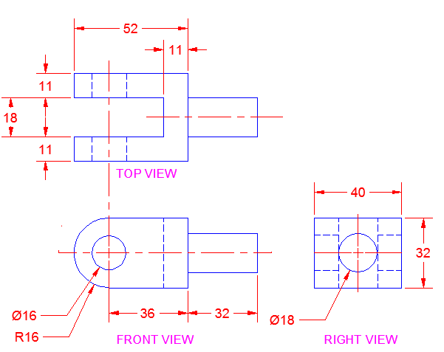

1. Draw the isometric projection of a sphere of radius 20mm when it is centrally located on a frustum of a cone. Base and top radii of cone are 35mm and 25mm respectively. Height of the pyramid = 50mm.
2. Draw the front view, top view and right side view for the given isometric view.

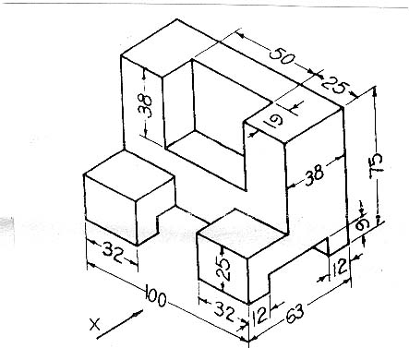

**--00 -- 00--**